ALY 6015 M2 Report - Thota, Sunil Raj.R

# Intermediate Analytics  
# ALY 6015  
# Module 1 - Hypothesis Testing with R  
# 01/30/2021  
# Sunil Raj Thota  
# NUID: 001099670

# Get and set the working directories  
getwd()

## [1] "G:/NEU/Coursework/2021 Q1 Winter/ALY 6015 IA/Discussions & Assignments"

setwd('G:/NEU/Coursework/2021 Q1 Winter/ALY 6015 IA/Discussions & Assignments')  
getwd()

## [1] "G:/NEU/Coursework/2021 Q1 Winter/ALY 6015 IA/Discussions & Assignments"

# Installed the above packages into the work space  
  
install.packages("datasets")  
install.packages("plyr")  
install.packages("dplyr")  
install.packages("tidyr")  
install.packages("tidyverse")  
install.packages("ggplot2")  
install.packages("ggcorrplot")  
  
# Loaded the below libraries into the workspace

library(plyr)

library(dplyr)

library(tidyr)

library(tidyverse)

library(ggplot2)

library(ggcorrplot)

require(grDevices)

require(datasets)

data(mtcars) # Load the mtcars Data set into the Environment  
View(mtcars) # To View the mtcars Data set  
head(mtcars) # It shows first few rows in the Data set

## mpg cyl disp hp drat wt qsec vs am gear carb  
## Mazda RX4 21.0 6 160 110 3.90 2.620 16.46 0 1 4 4  
## Mazda RX4 Wag 21.0 6 160 110 3.90 2.875 17.02 0 1 4 4  
## Datsun 710 22.8 4 108 93 3.85 2.320 18.61 1 1 4 1  
## Hornet 4 Drive 21.4 6 258 110 3.08 3.215 19.44 1 0 3 1  
## Hornet Sportabout 18.7 8 360 175 3.15 3.440 17.02 0 0 3 2  
## Valiant 18.1 6 225 105 2.76 3.460 20.22 1 0 3 1

tail(mtcars) # It shows last few rows in the Data set

## mpg cyl disp hp drat wt qsec vs am gear carb  
## Porsche 914-2 26.0 4 120.3 91 4.43 2.140 16.7 0 1 5 2  
## Lotus Europa 30.4 4 95.1 113 3.77 1.513 16.9 1 1 5 2  
## Ford Pantera L 15.8 8 351.0 264 4.22 3.170 14.5 0 1 5 4  
## Ferrari Dino 19.7 6 145.0 175 3.62 2.770 15.5 0 1 5 6  
## Maserati Bora 15.0 8 301.0 335 3.54 3.570 14.6 0 1 5 8  
## Volvo 142E 21.4 4 121.0 109 4.11 2.780 18.6 1 1 4 2

summary(mtcars) # Provides the Descriptive Stats of the mtcars Data set

## mpg cyl disp hp   
## Min. :10.40 Min. :4.000 Min. : 71.1 Min. : 52.0   
## 1st Qu.:15.43 1st Qu.:4.000 1st Qu.:120.8 1st Qu.: 96.5   
## Median :19.20 Median :6.000 Median :196.3 Median :123.0   
## Mean :20.09 Mean :6.188 Mean :230.7 Mean :146.7   
## 3rd Qu.:22.80 3rd Qu.:8.000 3rd Qu.:326.0 3rd Qu.:180.0   
## Max. :33.90 Max. :8.000 Max. :472.0 Max. :335.0   
## drat wt qsec vs   
## Min. :2.760 Min. :1.513 Min. :14.50 Min. :0.0000   
## 1st Qu.:3.080 1st Qu.:2.581 1st Qu.:16.89 1st Qu.:0.0000   
## Median :3.695 Median :3.325 Median :17.71 Median :0.0000   
## Mean :3.597 Mean :3.217 Mean :17.85 Mean :0.4375   
## 3rd Qu.:3.920 3rd Qu.:3.610 3rd Qu.:18.90 3rd Qu.:1.0000   
## Max. :4.930 Max. :5.424 Max. :22.90 Max. :1.0000   
## am gear carb   
## Min. :0.0000 Min. :3.000 Min. :1.000   
## 1st Qu.:0.0000 1st Qu.:3.000 1st Qu.:2.000   
## Median :0.0000 Median :4.000 Median :2.000   
## Mean :0.4062 Mean :3.688 Mean :2.812   
## 3rd Qu.:1.0000 3rd Qu.:4.000 3rd Qu.:4.000   
## Max. :1.0000 Max. :5.000 Max. :8.000

mtcars$am <- factor(mtcars$am)  
mtcars$am

## [1] 1 1 1 0 0 0 0 0 0 0 0 0 0 0 0 0 0 1 1 1 0 0 0 0 0 1 1 1 1 1 1 1  
## Levels: 0 1

str(mtcars) # To observe the structure of the Data set

## 'data.frame': 32 obs. of 11 variables:  
## $ mpg : num 21 21 22.8 21.4 18.7 18.1 14.3 24.4 22.8 19.2 ...  
## $ cyl : num 6 6 4 6 8 6 8 4 4 6 ...  
## $ disp: num 160 160 108 258 360 ...  
## $ hp : num 110 110 93 110 175 105 245 62 95 123 ...  
## $ drat: num 3.9 3.9 3.85 3.08 3.15 2.76 3.21 3.69 3.92 3.92 ...  
## $ wt : num 2.62 2.88 2.32 3.21 3.44 ...  
## $ qsec: num 16.5 17 18.6 19.4 17 ...  
## $ vs : num 0 0 1 1 0 1 0 1 1 1 ...  
## $ am : Factor w/ 2 levels "0","1": 2 2 2 1 1 1 1 1 1 1 ...  
## $ gear: num 4 4 4 3 3 3 3 4 4 4 ...  
## $ carb: num 4 4 1 1 2 1 4 2 2 4 ...

hist(  
 mtcars$mpg,  
 ylab = "Frequency",  
 xlab = "MPG",  
 breaks = 10,  
 xlim = c(min(mtcars$mpg), 35),  
 main = "MPG Histogram",  
 ylim = c(0, 8),  
 col = "brown1",  
 border = FALSE  
) # Histogram of mpg

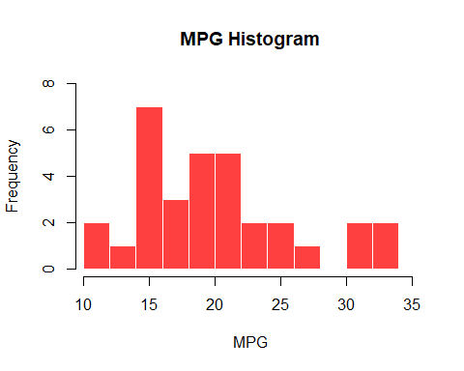

plot(  
 density(mtcars$mpg),  
 main = "Density Plot - MPG",  
 xlab = "MPG",  
 ylab = "Probability",  
 col = "purple"  
) # Density Plot of mpg

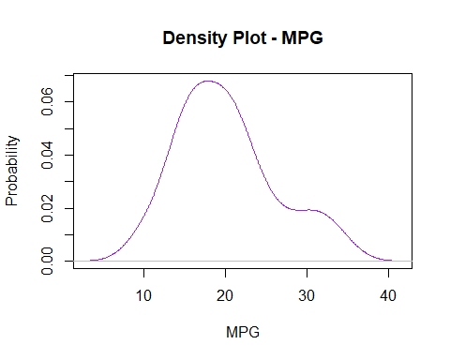

hist(  
 mtcars$disp,  
 ylab = "Frequency",  
 xlab = "DISP",  
 breaks = 9,  
 xlim = c(min(mtcars$mpg), 500),  
 main = "DISP Histogram",  
 ylim = c(0, 8),  
 col = "darkorchid",  
 border = FALSE  
) # Histogram of disp

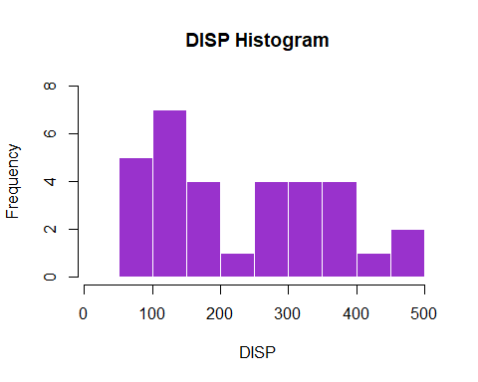

plot(  
 density(mtcars$disp),  
 main = "Density Plot - DISP",  
 xlab = "DISP",  
 ylab = "Probability",  
 col = "purple"  
) # Density Plot of disp

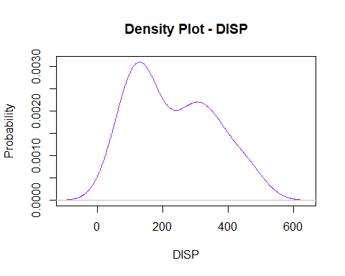

plot(  
 x = mtcars$mpg,  
 y = mtcars$am,  
 xlab = "MPG",  
 ylab = "AM",  
 main = "Relationship between mpg and am",  
 col = "purple",  
 pch = 20,  
 xlim = c(min(mtcars$mpg), max(mtcars$mpg))  
) # Scatter Plot is used to depict the relationship between the MPG and AM

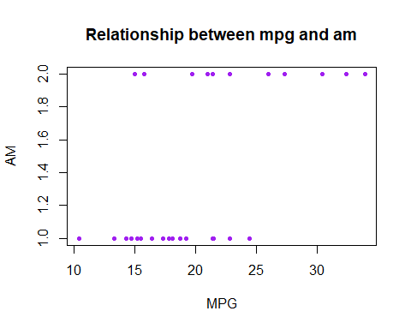

boxPltMPGandAM <-  
 data.frame(mtcars$mpg, mtcars$am) # Boxplot of mpg and am  
ggplot(boxPltMPGandAM,  
 aes(  
 x = mtcars$am,  
 y = mtcars$mpg,  
 fill = mtcars$am  
 )) + geom_boxplot(color = "brown",  
 alpha = 0.3,  
 fill = "purple") + ggtitle("am ~ mpg Boxplot") + ylab("mpg") + xlab("am") + theme_bw() # GGplot is used to plot the Boxplot

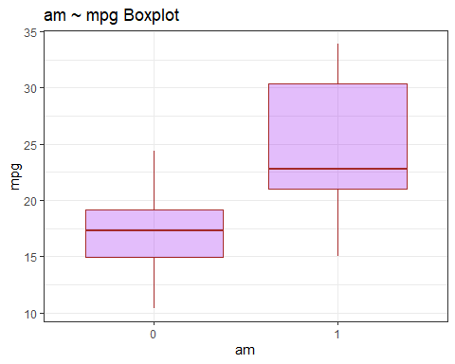

lmFit <- lm(mpg ~ am, data = mtcars)  
lmFit # Linear Model relationship between mpg and am in mtcars dataset

##   
## Call:  
## lm(formula = mpg ~ am, data = mtcars)  
##   
## Coefficients:  
## (Intercept) am1   
## 17.147 7.245

summary(lmFit) # Summary Stats of the linear model

##   
## Call:  
## lm(formula = mpg ~ am, data = mtcars)  
##   
## Residuals:  
## Min 1Q Median 3Q Max   
## -9.3923 -3.0923 -0.2974 3.2439 9.5077   
##   
## Coefficients:  
## Estimate Std. Error t value Pr(>|t|)   
## (Intercept) 17.147 1.125 15.247 1.13e-15 ***  
## am1 7.245 1.764 4.106 0.000285 ***  
## ---  
## Signif. codes: 0 '***' 0.001 '**' 0.01 '*' 0.05 '.' 0.1 ' ' 1  
## Residual standard error: 4.902 on 30 degrees of freedom  
## Multiple R-squared: 0.3598, Adjusted R-squared: 0.3385   
## F-statistic: 16.86 on 1 and 30 DF, p-value: 0.000285

rSquared <- summary(lmFit)$r.squared  
rSquared # r squared value

## [1] 0.3597989

lmFitAll <- lm(mpg ~ wt + am + wt:am + qsec, data = mtcars)  
lmFitAll # Linear Model relationship between mpg and all other parameters in mtcars dataset

##  
## Call:  
## lm(formula = mpg ~ wt + am + wt:am + qsec, data = mtcars)  
##   
## Coefficients:  
## (Intercept) wt am1 qsec wt:am1   
## 9.723 -2.937 14.079 1.017 -4.141

summary(lmFitAll) # Summary Stats of the linear model

##   
## Call:  
## lm(formula = mpg ~ wt + am + wt:am + qsec, data = mtcars)  
##   
## Residuals:  
## Min 1Q Median 3Q Max   
## -3.5076 -1.3801 -0.5588 1.0630 4.3684   
##   
## Coefficients:  
## Estimate Std. Error t value Pr(>|t|)   
## (Intercept) 9.723 5.899 1.648 0.110893   
## wt -2.937 0.666 -4.409 0.000149 ***  
## am1 14.079 3.435 4.099 0.000341 ***  
## qsec 1.017 0.252 4.035 0.000403 ***  
## wt:am1 -4.141 1.197 -3.460 0.001809 **   
## ---  
## Signif. codes: 0 '***' 0.001 '**' 0.01 '*' 0.05 '.' 0.1 ' ' 1  
##   
## Residual standard error: 2.084 on 27 degrees of freedom  
## Multiple R-squared: 0.8959, Adjusted R-squared: 0.8804   
## F-statistic: 58.06 on 4 and 27 DF, p-value: 7.168e-13

rSquaredAll <- summary(lmFitAll)$r.squared  
rSquaredAll # r squared value

## [1] 0.8958514

confint(lmFitAll) # confidence interval of the Linear Model

## 2.5 % 97.5 %  
## (Intercept) -2.3807791 21.826884  
## wt -4.3031019 -1.569960  
## am1 7.0308746 21.127981  
## qsec 0.4998811 1.534066  
## wt:am1 -6.5970316 -1.685721

par(mfrow = c(2, 2)) # To form the Plots in a 2X2 matrix  
plot(lmFitAll, which = 1:4)# Plotted the residuals vs fitted, normal QQ, Scale-location, and Cooks distance plots

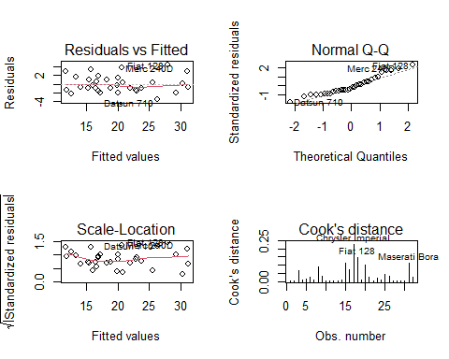

tTestMPG <- t.test(mtcars$mpg, mu = 20)  
tTestMPG # Performed One-sample T Test

## One Sample t-test  
##   
## data: mtcars$mpg  
## t = 0.08506, df = 31, p-value = 0.9328  
## alternative hypothesis: true mean is not equal to 20  
## 95 percent confidence interval:  
## 17.91768 22.26357  
## sample estimates:  
## mean of x   
## 20.09062

twoSampleTTest <-  
 t.test(  
 mpg ~ am,  
 data = mtcars,  
 var.equal = FALSE,  
 paired = FALSE ,  
 conf.level = .95  
 )  
twoSampleTTest # Performed Two-sample T Test

##   
## Welch Two Sample t-test  
##   
## data: mpg by am  
## t = -3.7671, df = 18.332, p-value = 0.001374  
## alternative hypothesis: true difference in means is not equal to 0  
## 95 percent confidence interval:  
## -11.280194 -3.209684  
## sample estimates:  
## mean in group 0 mean in group 1   
## 17.14737 24.39231

tTestPaired <-  
 t.test(mtcars$mpg,  
 mtcars$disp,  
 paired = TRUE,  
 alternative = "less")  
tTestPaired # Performed Paired T Test

##   
## Paired t-test  
##   
## data: mtcars$mpg and mtcars$disp  
## t = -9.2303, df = 31, p-value = 1.047e-10  
## alternative hypothesis: true difference in means is less than 0  
## 95 percent confidence interval:  
## -Inf -171.9404  
## sample estimates:  
## mean of the differences   
## -210.6312

tableDataSet <- table(mtcars$mpg, mtcars$am)  
propTestMtcars <- prop.test(tableDataSet,  
 conf.level = 0.95,  
 alternative = "two.sided")

## Warning in prop.test(tableDataSet, conf.level = 0.95, alternative =  
## "two.sided"): Chi-squared approximation may be incorrect

propTestMtcars # Performed Prop Test

##   
## 25-sample test for equality of proportions without continuity  
## correction  
##   
## data: tableDataSet  
## X-squared = 27.854, df = 24, p-value = 0.2662  
## alternative hypothesis: two.sided  
## sample estimates:  
## prop 1 prop 2 prop 3 prop 4 prop 5 prop 6 prop 7 prop 8 prop 9 prop 10   
## 1.0 1.0 1.0 1.0 0.0 1.0 1.0 0.0 1.0 1.0   
## prop 11 prop 12 prop 13 prop 14 prop 15 prop 16 prop 17 prop 18 prop 19 prop 20   
## 1.0 1.0 1.0 1.0 0.0 0.0 0.5 1.0 0.5 1.0   
## prop 21 prop 22 prop 23 prop 24 prop 25   
## 0.0 0.0 0.0 0.0 0.0

varTestMtcars <-  
 var.test(mtcars$mpg, mtcars$disp)  
varTestMtcars # Performed Var Test

##   
## F test to compare two variances  
##   
## data: mtcars$mpg and mtcars$disp  
## F = 0.0023647, num df = 31, denom df = 31, p-value < 2.2e-16  
## alternative hypothesis: true ratio of variances is not equal to 1  
## 95 percent confidence interval:  
## 0.001154324 0.004844338  
## sample estimates:  
## ratio of variances   
## 0.002364727